After a slight delay in receiving *Model Release Forms* from everyone, some long awaited (or dreaded) pictures from the Ricci Family Reunion are now available for your viewing pleasure/terror. Please follow the link below:

***( hyperlink removed to ensure privacy – please refer to your individual email or contact Bob for link)***

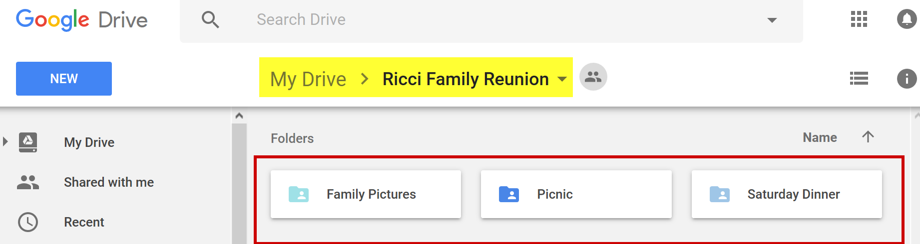

Since this is on Google Drive, it should be available to everyone regardless of OS or browser.

The share is configured so that everyone can view/add/edit/download. ***SO***…please **feel free to add** any photos that you would like to share or download any that you would like to keep . You can add photos in existing folders or create new folders if you wish.

Sincerely,

***RFROC (Ret)***