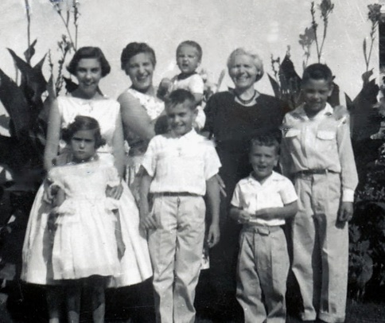***Picture This!***

Your RFROC subcommittee on media memories has arranged to have a ‘*Family Memories*’ station setup up as part of the Saturday meal at the Embassy Suites. There will be a laptop (windows OS) hooked up to a projector. Please bring a (USB) thumb drive with any photos that you would like to share. These will be loaded into a self-running slide show. Feel free to include photos (short videos?) of you and/or your family (individuals/gatherings/vacations/etc). Contributor discretion is advised. Please do not include any selfies that you may have received from Anthony Weiner.